
MINISTRY OF EDUCATION, CULTURE AND RESEARCH
OF THE REPUBLIC OF MOLDOVA
Technical University of Moldova
Faculty of Computers, Informatics and Microelectronics
Department of Software Engineering and Automation

Clepicova Polina FAF-243

Report
Laboratory Works No.3-4
Operating Systems
Topics: The Command Line, The xv6 Shell

Checked by:
Reitman P., univ.assistant
FCIM, UTM

Chișinău – 2026

TABLE OF CONTENTS
LABORATORY 3 – BEFORE YOU START 3
LABORATORY 3 - PART 1 3
PART 1. OBSERVE ANSWERS 8
LABORATORY 3 - PART 2 9
Part 2. Observe Answers 10
LABORATORY 3 - PART 3 12
Part 3. Observe Answers 13
LABORATORY 3 - PART 4 15
LABORATORY 3 - PART 5 16
Part 5. Observe Answers 16
SUMMARY FOR LABORATORY 3 17
LABORATORY 4 – BEFORE YOU START 18
LABORATORY 4 – PART 1 18
LABORATORY 4 – PART 2 21
Part 2. Observe Answers 23
LABORATORY 4 – PART 3 25
Part 3. Observe Answers 27
LABORATORY 4 – PART 4 29
Part 4. Observe Answers 30
SUMMARY FOR LABORATORY 4 31

LABORATORY 3 – BEFORE YOU START
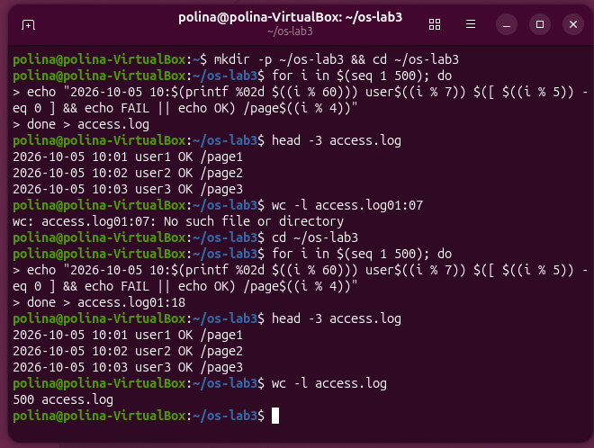
Figure 3.1.1 - Generating access.log dataset
Generating a synthetic dataset of 500 web log entries using a Bash for loop and checking its total line count using wc -l.

LABORATORY 3 - PART 1

Figure 1.2 - Tab completion
Demonstrating auto-completion in Bash using the Tab key to expand paths and directory names.
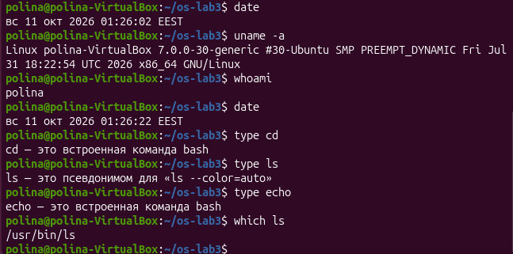
Figure 3.1.3 - Output of type and which
Checking basic system commands (date, uname -a, whoami), determining whether commands are shell built-ins or external binaries (type), and locating the path of executables (which).
Figure 3.1.4 - The directories in PATH
Inspecting the $PATH environment variable and splitting its colon-separated directories into individual lines using tr.

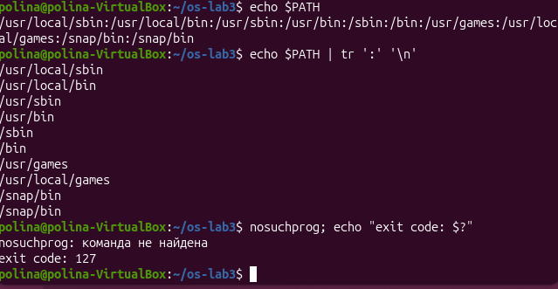
Figure 3.1.5 - Exit code of a missing command
Running a non-existent command (nosuchprog) and verifying its return exit code of 127 using $?.
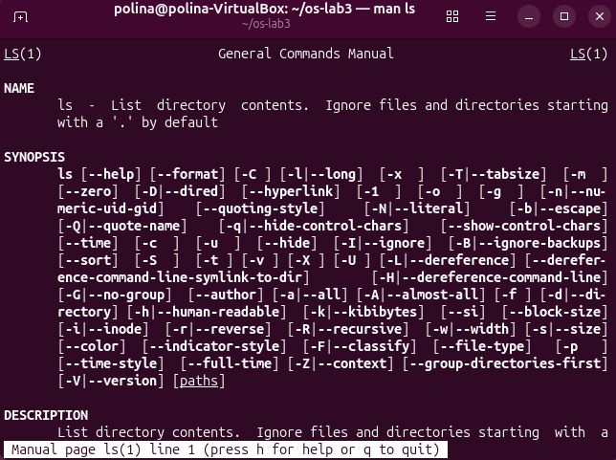
Figure 3.1.6 - Command manual page for ls
Displaying system documentation for the ls command using the man utility.

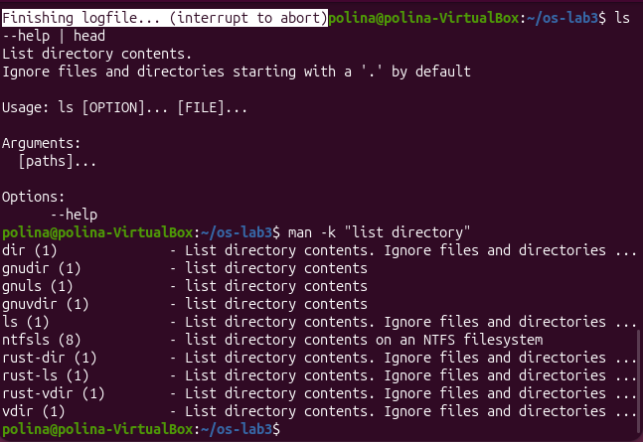
Figure 3.1.7 - Getting command help and searching manual pages
Viewing quick help for ls using --help and searching manual page descriptions with man -k.

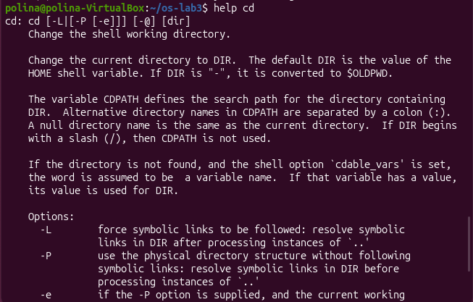
Figure 3.1.8.1 - Shell builtin help for cd
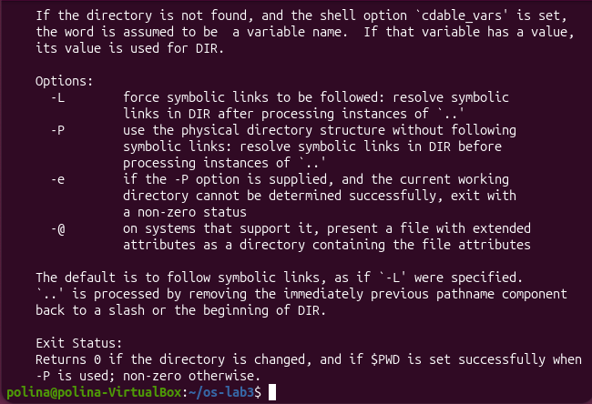
Figure 3.1.8.2 - Shell builtin help for cd
Displaying documentation for the shell builtin command cd using the help utility.

PART 1. OBSERVE ANSWERS
- Which of cd, ls, echo are built-ins, and why MUST cd be one?
cd is a shell builtin.
echo is a shell builtin (though a standalone binary /bin/echo often exists as well).
ls is an external program (located at /usr/bin/ls or /bin/ls).
Why cd must be a builtin: The cd command changes the current working directory of the process. In Unix/Linux, a child process cannot modify the working directory of its parent process. If cd were an external executable, the shell would fork a new child process to run it; the child process would change its own working directory and terminate immediately, leaving the main shell's working directory unchanged.
- How many directories are in your PATH, and in which one is ls?
Directories in PATH: You can count them by running echo $PATH | tr ':' '\n' | wc -l. (Usually between 5 and 9 directories, depending on your Linux distribution).
Location of ls: It is located in /usr/bin/ls (or /bin/ls), as shown by running which ls.
- What exit code does a command that is not found return?
A command that is not found returns an exit code of 127.
- Which option of ls sorts by modification time?
The -t option sorts entries by modification time (newest first).

LABORATORY 3 - PART 2
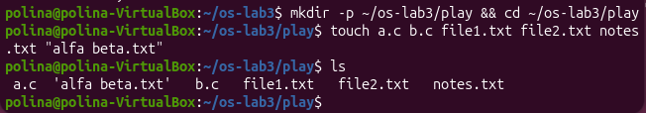
Figure 3.2.1 - Files created in the play directory
Creating a test directory and creating sample files with various extensions and names using touch.

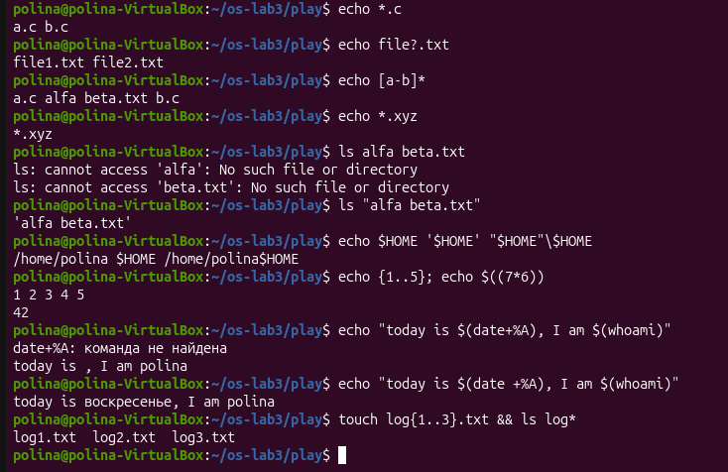
Figure 3.2.2 - Wildcard expansion, quotation, and subshell evaluation
Testing pathname expansion (globbing) with *, ?, and [], demonstrating how unquoted spaces split arguments, and evaluating quotes and subshells.

Part 2. Observe Answers
- Table of predictions and real outputs:
(Refer to the table provided in the previous step for the full break-down of echo *.c, ls alfa beta.txt, quote behaviors, and brace expansion).
- echo knows nothing about files, yet echo *.c printed file names. Who produced them?
  - The file names were produced by the shell (bash) via pathname expansion (globbing) before passing the resulting arguments to the echo command.
- Why did ls alfa beta.txt fail? Give two different ways to fix it.
  - Reason for failure: The shell treats unquoted spaces as argument separators. It passed two separate arguments (alfa and beta.txt) to ls, neither of which exists individually.
  - Fix 1 (Double/Single Quotes): ls "alfa beta.txt"
  - Fix 2 (Backslash Escaping): ls alfa\ beta.txt
- What is the difference between single and double quotes?
Single quotes ('...'): Suppress all expansions. Everything inside is treated strictly as literal text (variables like $VAR and command substitutions like $(cmd) are not evaluated).
Double quotes ("..."): Prevent word splitting on spaces, but still allow variable expansion ($VAR), command substitution ($(cmd)), and arithmetic expansion ($((...))).
Note on ls output format: ls wraps filenames containing spaces in single quotes (e.g., 'alfa beta.txt') to visually indicate to the user that it is a single file with spaces in its name rather than two separate files.

Command | My prediction | Real output | Explanation (if different)
echo .c | a.c с.c | a.c b.c | The shell expands .c (globbing) to matching filenames before executing echo.
echo file?.txt | file.txt file.txt | file1.txt file2.txt | The ? wildcard matches exactly one single character.
echo [a-b] | a. alfa beta.txt b. | a.c alfa beta.txt b.c | Matches all filenames starting with letters from a to b.
echo .xyz | .xyz | .xyz | No files matched, so the shell passes the pattern as a literal argument.
ls alfa beta.txt | Error output | ls: cannot access 'alfa': No such file... / ls: cannot access 'beta.txt': No such file... | The shell splits arguments by unquoted spaces and looks for two separate files.
ls "alfa beta.txt" | alfa beta.txt | alfa beta.txt | Double quotes group the string with space into a single argument.
echo $HOME '$HOME' "$HOME" $HOME | /home/ $HOME /home/ $HOME | /home/polina $HOME /home/polina$HOME | Single quotes and backslash disable variable expansion.
echo {1..5}; echo $((7*6)) | 1 2 3 4 5 / 42 | 1 2 3 4 5 / 42 | Demonstrates brace expansion {1..5} and arithmetic evaluation$((7*6)).
echo "today is $(date +\%A), I am$(whoami)" | today is Sunday, I am polina | today is Sunday, I am polina | Double quotes allow command substitution for $(date) and$(whoami).
touch log{1..3}.txt && ls log | log1.txt log2.txt log3.txt | log1.txt log2.txt log3.txt | Creates files using brace expansion and lists them using the log glob.

LABORATORY 3 - PART 3
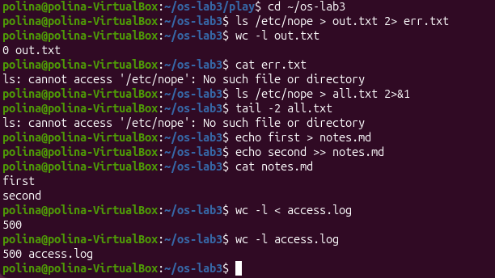
Figure 3.3.1 - Output and error redirection
Redirecting standard output (>) and standard error (2>), appending to files (>>), and passing files via standard input (<).

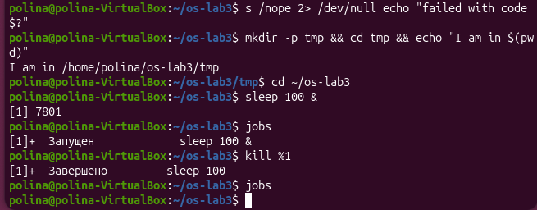
Figure 3.3.2 - Output and error redirection
Executing conditional command chains with && and ||, running background tasks with &, and managing jobs using jobs and kill.

Part 3. Observe Answers
- Which file got the error message, and which got the listing?
err.txt got the error message because standard error was redirected using 2> err.txt.
out.txt got the standard output redirection (> out.txt), but because the command failed, out.txt remained empty.
- What is the difference between > all.txt 2>&1 and 2>&1 > all.txt?
> all.txt 2>&1: First, standard output (stdout) is redirected to all.txt. Then, standard error (stderr, 2) is redirected to point to the same destination as stdout (which is all.txt). Both outputs end up in all.txt.
2>&1 > all.txt: First, stderr (2) is redirected to point to where stdout currently points (the terminal). Then, stdout is redirected to all.txt. Consequently, error messages appear on the terminal screen, while standard output goes into all.txt.
- Why does wc -l < access.log print only a number, while wc -l access.log also prints the file name?
In wc -l access.log, the filename is passed as a command-line argument, so wc knows the name and displays it alongside the line count.
In wc -l < access.log, input is redirected to wc's standard input stream (stdin). The wc tool reads from an anonymous stream and does not know the original file name, so it outputs only the number.
- Explain each operator in one sentence: ;, &&, ||:
; — Sequentially runs commands one after another regardless of whether the previous command succeeded or failed.
&& — Runs the next command only if the previous command succeeded (exit code 0).
|| — Runs the next command only if the previous command failed (exit code non-zero).

LABORATORY 3 - PART 4
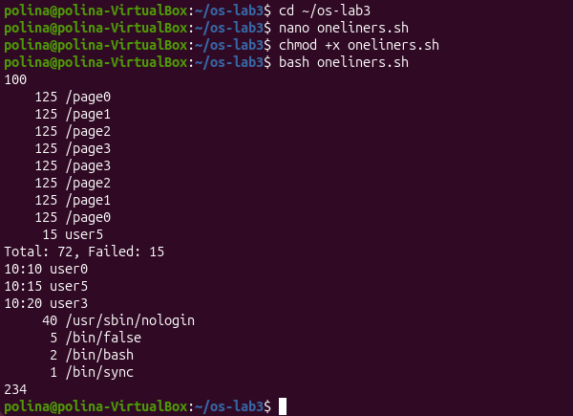
Figure 3.4.1 - Execution of oneliners.sh
Making oneliners.sh executable and running single-line command pipelines to extract analytical answers from access.log and system files.

LABORATORY 3 - PART 5
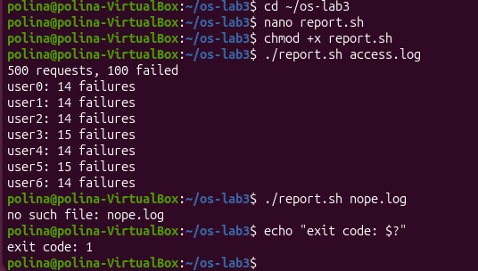
Figure 3.5.1 - Execution and error handling of report.sh
Running the custom Bash script report.sh on access.log to print failure statistics per user and testing error handling on a missing log file.

Part 5. Observe Answers
- What does the first line #!/bin/bash do, and what happens if you run ./report.sh before chmod +x?
#!/bin/bash (Shebang): Specifies the path to the interpreter that the kernel should use to execute the script.
Running before chmod +x: The OS will deny execution and return a Permission denied error because the file lacks executable permissions (x).
- Why must you type ./report.sh and not just report.sh?
The current working directory (.) is not in the system's $PATH variable for security reasons. Typing report.sh causes the shell to search only directories in $PATH, leading to a command not found error. Adding ./ explicitly specifies the path to the script in the current directory.
- Why does the script write the error with >&2 and end with exit 1?
>&2: Redirects the error message to standard error (stderr) so it does not pollute standard output (stdout) or break downstream pipelines.
exit 1: Terminates the script with a non-zero exit status, signaling to the caller or parent process that the execution failed due to an error.

SUMMARY FOR LABORATORY 3
In this laboratory work, I gained practical experience working with the Linux command-line interface (Bash).
- Command Navigation & Help Systems: I mastered fast terminal navigation using Tab completion and command history search (Ctrl+R). I learned how to distinguish between shell built-ins and external executables using type and which, inspected system environment variables ($PATH), and retrieved system documentation using man, help, and man -k.
- Shell Expansion & Globbing: I analyzed how the Bash shell parses and expands command lines before execution, including pathname expansion (globbing with *, ?, []), quote behavior (single vs. double quotes), brace expansion ({1..n}), and command substitution.
- Redirection, Pipelines & Job Control: I practiced I/O redirection using standard output (>), append (>>), standard error (2>), combined streams (2>&1), and standard input (<). I explored command chaining using ;, &&, and ||, as well as process management using background execution (&), jobs, and kill.
- Text Processing & One-Liners: I built multi-stage pipelines using core Linux text filters (grep, cut, sort, uniq, wc, awk, head, tail) to process and extract meaningful analytical data from log files.
- Scripting & Automation: I developed an executable Bash script (report.sh) featuring argument parsing, file checking error handling (>&2, exit 1), and iteration constructs (for loops). Additionally, I configured automated task execution via cron.

LABORATORY 4 – BEFORE YOU START
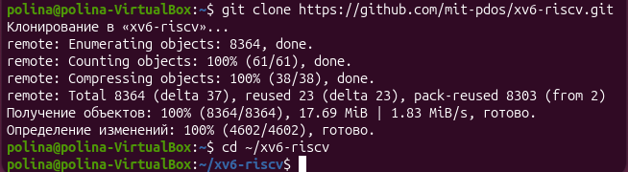
Figure 4.1.1 – git clone and cd ~/xv6-riscv

LABORATORY 4 – PART 1
Figure 4.1.2 - Execution and error handling of report.sh
Checking user/user.h to identify whether the current xv6 kernel uses the updated system call declaration pause() instead of sleep().

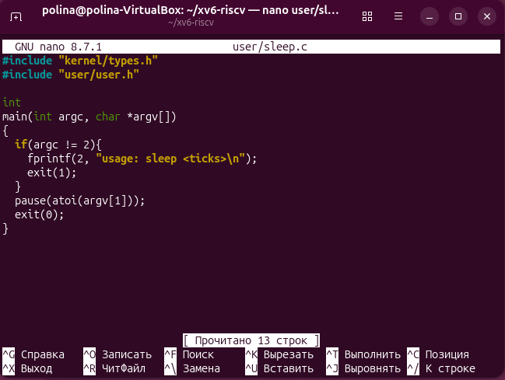
Figure 4.1.3 - The updated sleep.c.
Source code of user/sleep.c updated to invoke pause() and handle argument checking correctly.
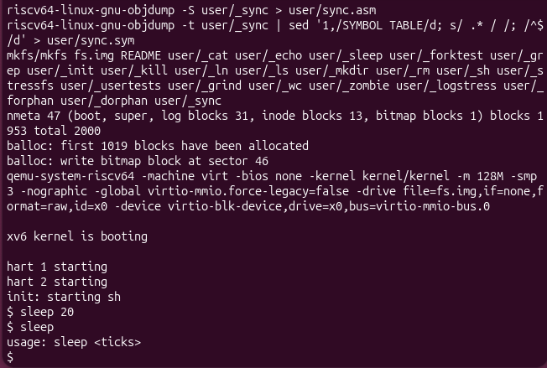
Figure 4.1.4 - sleep running in xv6, with and without an argument
Testing the sleep command inside QEMU for xv6, verifying both successful execution with an argument and usage error handling when run without arguments.

LABORATORY 4 – PART 2
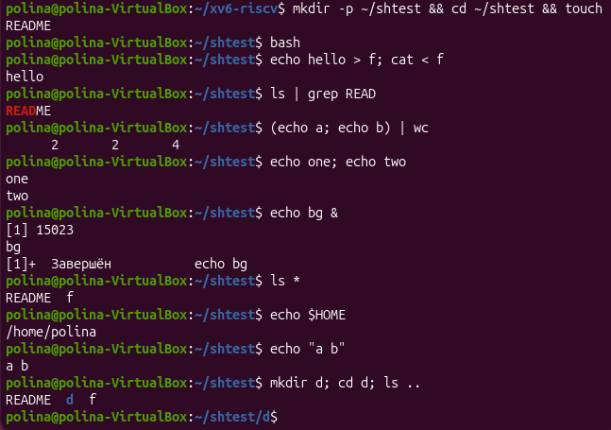
Figure 4.2.1 - The commands run in bash.
Executing test commands (redirection, pipes, lists, background jobs, globbing, variables, quotes, history) in bash on Linux inside the ~/shtest directory.
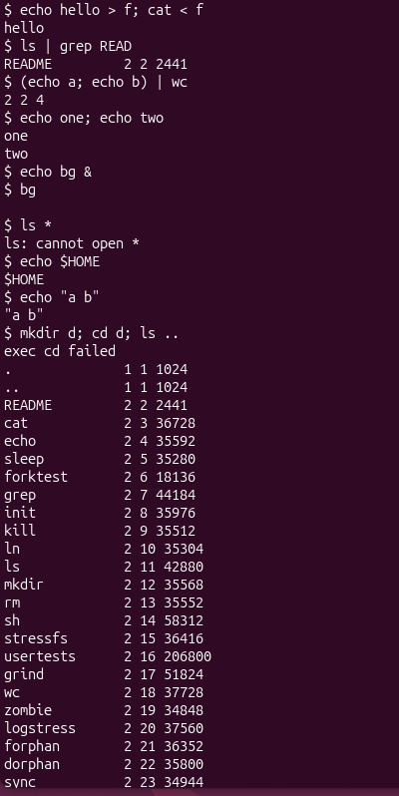
Figure 4.2.2 - The same commands run in xv6.
Executing the identical set of test commands inside the xv6 shell to evaluate differences in features and expansion capabilities.
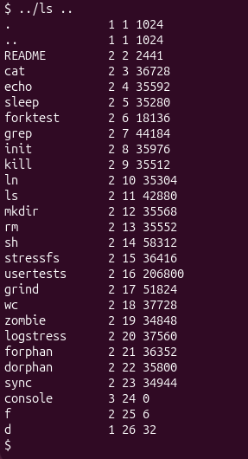
Figure 4.2.3 - ls failing after cd d, and the working alternative.
Demonstrating that ls fails inside directory d due to the lack of $PATH in xv6, and executing it successfully using the relative path ../ls ...

Part 2. Observe Answers
- List the features both shells have, and the ones only bash has.
Features both shells have: Basic I/O redirection (>, <), simple pipelines (|), command sequencing (;), and background process execution (&).
Features only bash has: Command grouping (), wildcard globbing (*), environment variable expansion ($VAR), quote stripping ("" / ''), $PATH environment variable lookup, path completion (Tab), and command history (Up arrow, Ctrl+R).
- In xv6, ls stops working after cd d. Why? Find a way to run ls from inside d anyway.
Reason for failure: The xv6 shell lacks support for the $PATH environment variable. It looks for executable binaries only within the current working directory. Upon navigating into directory d, the shell attempts to execute /d/ls, which does not exist.
Working alternative: Execute ls using a relative path targeting the binary in the root directory: ../ls .. (or using the absolute path /ls ..).
- Which missing feature would you miss most in daily work, and which would be easiest to add?
Most missed feature: $PATH environment variable resolution and command-line history/tab completion, as both are essential for efficiency during terminal navigation.
Easiest feature to add: Basic environment variable expansion (such as parsing $HOME or $VAR) or simple wildcard globbing (*).

LABORATORY 4 – PART 3
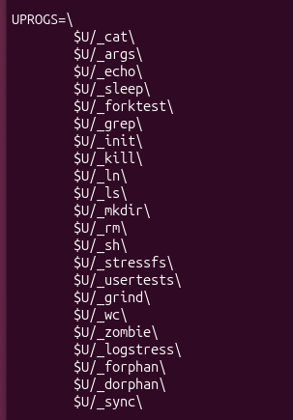
Figure 4.3.1 - args.c and the UPROGS line.
Implementation of user/args.c to display argc and argv contents, alongside its entry in UPROGS inside Makefile.
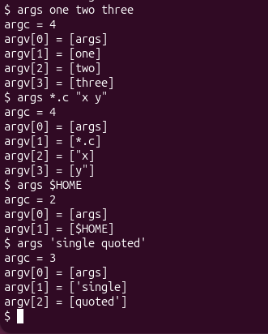
Figure 4.3.2 - args output in xv6.
Running args in xv6 with arguments containing *, quotes, and $, showing that arguments are passed literally without shell pre-processing.

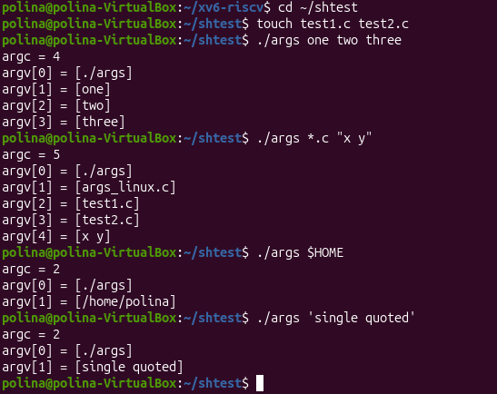
Figure 4.3.3 - args_linux output in bash.
Running args_linux in bash, proving that the Linux shell performs globbing (*.c), quote stripping, and variable expansion before passing arguments to the program.

Part 3. Observe Answers
- Paste both outputs for args *.c "x y". How many arguments did each program receive?
Output in xv6: The program received 3 arguments (argc = 3):
    - argv[0] = [args]
    - argv[1] = [*.c]
    - argv[2] = ["x y"]
Output in bash: The program received 4 arguments (argc = 4):
    - argv[0] = [./args]
    - argv[1] = [test1.c]
    - argv[2] = [test2.c]
    - argv[3] = [x y] (quotes stripped)
- So who turns *.c into file names and removes the quotes: the program, the kernel, or the shell?
The shell (bash) performs wildcard expansion (globbing) and strips double/single quotes before constructing the argv array and passing it to the program.
- What happened to the extra spaces in one two three?
Unquoted spaces serve as argument delimiters in the shell. The shell discards the extra whitespace and passes each distinct word as an individual element within the argv array.

LABORATORY 4 – PART 4

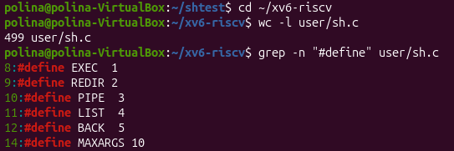
Figure 4.4.1 – The command kinds defined in sh.c
Inspected #define constants in user/sh.c representing the five internal command types (EXEC, REDIR, PIPE, LIST, BACK).
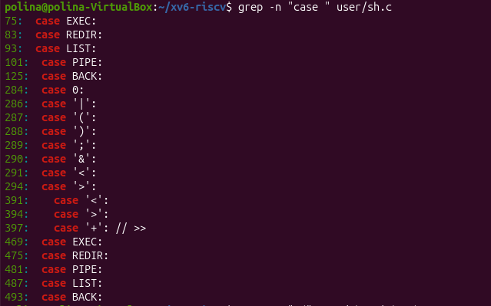
Figure 4.4.2 – Where each kind is run (grep -n "case " user/sh.c).
Located the switch/case statement in user/sh.c where each parsed command type is evaluated and executed.
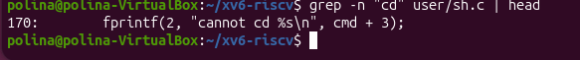
Figure 4.4.3 – The code that handles cd (grep -n "cd" user/sh.c | head).
Code segment in user/sh.c handling the builtin cd command directly in the shell process using chdir().

Part 4. Observe Answers
- Name the five kinds of command the xv6 shell knows and the character that produces each.
EXEC — Simple command execution (no special character).
REDIR — Redirection (< or >).
PIPE — Pipeline (|).
LIST — Command sequence (;).
BACK — Background execution (&).
- Where is cd handled, and why is it not run as a separate program?
cd is handled directly in main() of user/sh.c using the chdir() system call before executing any fork().
Reasoning: A child process created via fork() cannot alter the current working directory of its parent process. If cd were an external binary, the child process would change its own directory and terminate immediately, leaving the shell in the original directory.
- Search sh.c for any code that handles * or $. What does that explain about Part 2?
There is no code in user/sh.c that parses or expands * or $. This explains why in Part 2 xv6 printed $HOME literally and failed on ls * — the xv6 shell lacks wildcard globbing and variable expansion functionality entirely.

SUMMARY FOR LABORATORY 4
In this laboratory work, I studied the implementation and behavior of the xv6 operating system shell (user/sh.c) in comparison with the standard Linux bash shell.
- Fixing System Calls: I updated the sleep.c user utility to adapt to recent xv6-riscv kernel updates, replacing the deprecated sleep() system call with pause(), and configured Makefile to compile and link the executable into the disk image.
- Shell Feature Comparison: Through side-by-side experiments, I identified shared core features between bash and xv6 (I/O redirection >, <, pipelines |, command sequencing ;, background execution &). I observed that xv6 lacks path resolution ($PATH), wildcard globbing (*), quote stripping, environment variables ($VAR), and command history/completion.
- Argument Processing & Expansion: By implementing and running args.c in both environments, I proved that argument expansion (globbing and quote removal) is performed entirely by the shell (bash) before launching the binary, whereas the xv6 shell passes raw strings directly to the program.
- Internal Shell Architecture: By inspecting user/sh.c, I analyzed how the 500-line xv6 shell parses commands into five distinct types (EXEC, REDIR, PIPE, LIST, BACK) and confirmed that builtin commands like cd must be executed directly by the shell process to alter its current working directory.

